Name: ____________________________________________ Grade: 2- ___

Date: _______________________ **Week _____**

Choose the correct answer:

1. The ___________ draw thick lines. (Brush tool ,

Shape tool)

1. _________ allow you to choose shapes and sizes for some of the paint and draw tools.
2. _________ let you create all kinds of different shapes. (Tool option, shape tool)
3. The __________ tool draws a shape with four sides. (Rectangle, circle)
4. The __________________tool draws a round shape. (ellipse, rectangle)

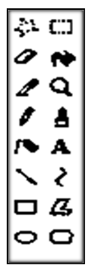

Label the Toolbox:

|  |  |  |
| --- | --- | --- |
| rectangle | Ellipse | Brush tool |