Name:______________________________________ gr 5( ) Date:________________________

Q4. Look at the following picture and answer

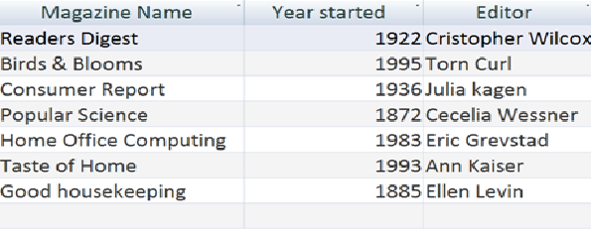

  - The given database has how many fields?_______________

  - The database consist of how many records?_____________

  - What is the field type for field Magazine?_______________

  - What is the field type for field year started?_____________

Page 1 of 1 Gr 5 database

